Maintenance
Manual

[picture PH-XXX }

Van's Aircraft RV-7

PH-XXX

© 2022 -by author
Document History
Date | Revision | Description | Author
19-09-2022 | 1.0 | Initial version | Author
04-01-2023 | 1.1 | Added chapter “ Regulation” | Author

Type Van's Aircraft
Model RV-7
Serial No. 74612
Engine Superior IO-360M1B
Propeller MT (MTV-12B)
Built September 2017 – October 2022
Builder Name
NVAV No. Number

Disclaimer
The Van's Aircraft RV-7 is classified as experimental, it has not been certified and does not comply with international safety regulations.

Flight characteristics such as high roll rate and light control forces can be more demanding to the pilots’ skill.

This airplane has been built by the builder to the best of his knowledge and quality of craftsmanship. Nonetheless, operating this airplane is at the sole risk of the pilot.

CONTENTS

Applicable regulation 5
Consumables 6
Lubrication 6
Maintenance Schedule 6
Service Bulletins 7
Torque Settings 8
Aircraft Handling and Care 9
Daily Check 10
Maintenance Inspections 14
Engine Test Run 20
Equipment list and Inventory 22

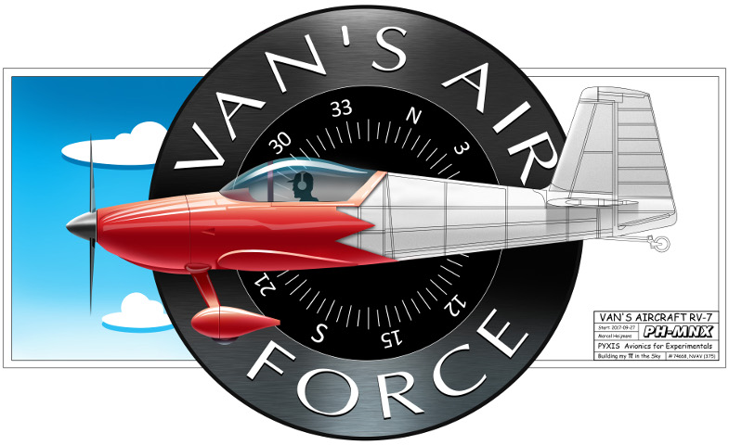

Applicable regulation

This maintenance manual is regulated by “Regeling nationale veiligheidsvoorschriften luchtvaartuigen” (The Regulation) https://wetten.overheid.nl/BWBR0043696

Referring to The Regulation article 33:

- 3°.bedrijfsgegevens;
This item is not applicable as PH-YAR is maintained by the pilot/owner. Contact details is as mentioned on the BVI (Bewijs van Inschrijving).
- 4°.de van toepassing zijnde aanwijzingen van de minister;
There are no items applicable under this member.
- 5°.aanvullende onderhoudsinformatie;
There are no items applicable under this member
- 6°.welk onderhoud eventueel door de piloot-eigenaar kan worden uitgevoerd.
All maintenance actions may be performed by pilot/owner within and according The Regulation.

-oOo-

Consumables
…

Lubrication

…

Maintenance Schedule
- ….

Service Bulletins
….

Torque Settings
….
Lycoming
…

Aircraft Handling and Care
…

Daily Check
…
Preflight
….

Preflight continued
…..
Preflight continued

aintenance Inspections
…

Engine Test Run
…..

Equipment list and Inventory

